SMART WATER MANAGEMENT

**INTRODUCTION**

Fountain is a Latin word representing "fontis" whose English meaning is water from a source that pours water into a basin or sprinkles into the air to supply drinking water or for a decorative purpose. Water fountains have become very popular over the last decade and everyday people are realizing the benefits a fountain can have. Some of the water fountain benefits are as follows: i. Stress Relief & Relaxation: Hearing the calming trickling sound of the falling water is soothing, calming, and mesmerizing. The relaxing ambience will easily enhance the serenity of the environment or garden. ii. Indoor & Outdoor décor: The water fountain will add instant beauty to the surroundings. iii. Natural Humidifier: Fountains act as natural humidifiers, adding moisture to a dry surrounding. It can also help indoor plants by adding extra humidity that is lost when heat or air conditioning units are running. iv. Wildlife Attraction: Fountains are great magnets for attracting wildlife, native, while discouraging mosquitoes, making them a great, eco-friendly and safe way to tackle pest control and reintroduce various animal species back to the area, benefitting the local ecosystem. v. Drowning Out Annoying Sounds A soft flowing water will help you relax and give you a new sound to enjoy, drowning out other sounds around you [2]. The term “Automatic sprinkler system” simply means automatic plant watering system which is an artificial method of water application to soil to enhance crop life. Nowadays, in the age of advanced technology and electronics, for the life of human being to be simpler and there is a need for many automated systems that can replace or reduce human effort in their daily activities and jobs. One of such system, named as automatic sprinkler system, is a model of controlling irrigation facilities that uses sensor technology to sense the moisture level of the soil with a microcontroller in order to make a smart switching electronic device to help billions of people. Irregular watering leads to the mineral loss in the soil and may end up with rotting the plants.

**ABSTRACT**

Manual plant watering has been an insistent problem in this era of technological advancement. An automatic sprinkler system for plant and automatic refill system for water fountain is a practical solution to minimize water loss and human errors encountered in manual watering. This project is a microcontroller based automatic refill system for water fountain and automatic sprinkler system for plants. It uses an ATmega328P microcontroller (MCU) IC that serves as the brain incorporated with a Real Time Clock (RTC) module to turn ON the sprinkler pump at a designated time and a soil moisture sensor that monitors the water level in the soil by comparing it with a preprogrammed threshold value. A float switch constantly monitors the water level in the fountain. When the water goes below a desired level, the float switch sends signal to the microcontroller that turns on the refill pump and when the water is at optimal level the refill pump automatically turns off. This project can improve the standard of living for humans and add instant beauty to our surroundings. The benefits of this project cannot be over emphasized.

**DESIGN**

The block diagram in figure 1 gives the short illustration of what the framework will do in this specific system. Arduino microcontroller is used to control the entire procedure of this Plant Watering System. The use of soil sensor circuit is straight forwardly associated with a computerized soil sensor stick with digital pins connected to Arduino. An idea for GSM module in this project is to notify the user by sending SMS. The schematic of the overall system is shown.

Block diagram of Arduino based automated plant watering system with message alert.

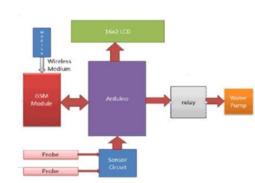

Real-Time Clock Controlled Herbal Garden Watering System Hygrometer sensors are usually used in smart garden watering system. However, they are known for corroding quickly, particularly if watering is required every day. This system takes advantage of RTC to trigger the watering of an herbal garden. The major components used in this project as shown in figure 2 are: 12V power pack, real time clock, relay, buzzer, and Arduino Nano. An Arduino Nano is used because it is smaller and takes less space. The real-time clock module is connected to the Arduino. The Arduino is programmed to turn ON the pump at a designated time. The pump is connected to the relay and 12V power through a 12mm PVC tube. The water supply is enabled through a 20 litre tank, enough to keep the watering for a few weeks. A float switch is connected to the bottom of the tank, that triggers an alarm if the water level goes below a critical level for the pump.

**METHODOLOGY**

The design procedure involves determining the appropriate materials and components to be used in the circuit as well as their properties; which includes components values, voltage ratings and maximum current ratings. These could be actualized easily by consulting the data sheet provided by component’s manufacturer. The analysis of each unit will be carried out in detail, for example, the value of capacitor in the power supply can only be determined by mathematical analysis where a formula is used and some important parameters such as total load current and frequency of mains voltage are used to calculate for the capacitance.

Aquarium auto refill with Arduino is a simple example of how to use a float switch, small liquid pump and a relay to refill an aquarium once the water level gets too low. But this same technique can be used for pet dishes, water fountains, or any other number of similar applications.

**SENSORS**

Soil Moisture Sensor The soil moisture sensor module is used to detect the moisture level of the soil. It measures the volumetric content of water inside the soil and gives the moisture level as output. The moisture sensor consists of two probes that are used to detect the moisture of the soil. These two probes are used to pass the current through the soil to the LM393 comparator IC, and then the sensor reads the resistance to get the moisture values. This Moisture sensor module consists of a moisture sensor, Resistors, Capacitor, Potentiometer, Comparator (LM393 IC), Power and Status LED in an integrated circuit. The moisture sensor probes are coated with immersion gold that protects Nickel from oxidation. as shown in figure.

**PROGRAM CYCLE**

The program cycle can be broken down into at least seven steps: i. Understand the problem. ii. Plan the logic. iii. Code the program. iv. Use software (a compiler or interpreter) to translate the program into machine language. v. Test the program. vi. Put the program into production. vii. Maintain the program. The problem has been properly understood, the problem involves designing an automatic refill system and an automatic sprinkler system with ground moisture sensor, which can also be triggered ON at designated time. With this the next step in this project is to plan the logic which the program will run. They will be done vividly in the next section with the help of flow chart. Flow Chart of the system Flowchart is a pictorial representation of the logic flow of the program, it helps to visualize more easily how the program statement will connect. The chart will be divided into two sections, one section is for the automatic sprinkler system and the other is for the automatic refill system. Figure 13 below is a pictorial representation of how the automatic refill system will operate, Figure 14 is a pictorial representation of the sprinkler system

**FLOW CHART**

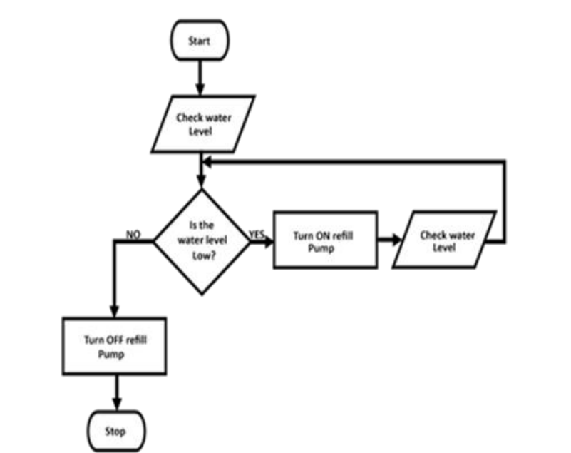

The ATmega328P microcontroller can be programmed with the Arduino IDE software. The Arduino microcontroller is an easy to use yet powerful single board computer that has gained considerable traction in the hobby and professional market. The Arduino is open source which means hardware is reasonably priced and development software is free. The IDE has the main sections, the void setup and void loop, the set up runs once immediately the circuit is turned. In the setup section, the programmer declares all the variables and setup the pin mode which could be input or output.

The loop section is where all the main code and instruction are written because it runs repeatedly. The Arduino is capable of which translating and executing about 300,000 lines of C source code per second. The source code used in this project will be shown in the appendix section.

**HARDWARE COMPONENTS**

The hardware consists of electronic component and electromechanical devices that comprises of physical devices. Electric hardware design is the analysis and synthesis of electronic circuit components. It deals with physical components and their interrelationships.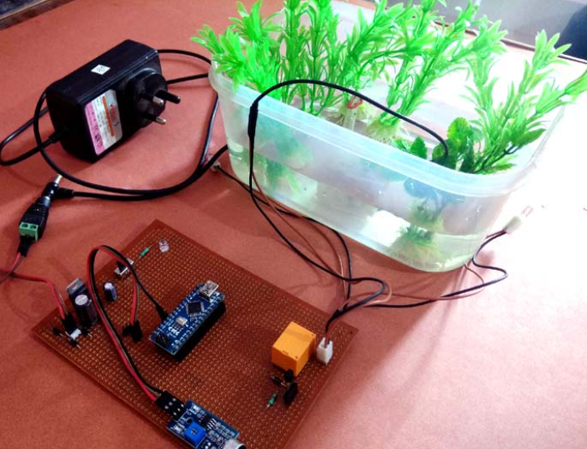

The circuit diagram of the system, TR1 is a stepdown transformer that steps down 230VAC to 15VAC, C1 and C2, and C5 are filter capacitors they are also used to stabilize the load fluctuations. U1 and U2 are voltage regulators, U2 is LM317C is a variable voltage regulator, for this project it is set as a 12V voltage regulator whereas L7805C is a constant 5V voltage regulator. D1, D2, D3, D4, D5 and D6 are PN junction diode they are used to protect the transistor and regulators from charges stored in the relay coil and motor coil, they can also e called freewheeling diodes. Q1, Q2 and Q3 are NPN transistors, they are biased to operate as a switch and current amplifiers. R1 and RV1 are resistor that form a voltage divider circuit for U2 voltage regulator. RL1, RL2 and RL3 are relays used to trigger the pumps. U3 is the ATmega328P microcontroller chip.

**CONCLUSION**

The problems associated with manual watering inspired the development of this project. The system utilizes a Real time clock module that sends signal to turns ON the sprinkler system at designated time and with the help of a soil moisture sensor the system could be able to detect when the water in the soil is enough in order to turn OFF the pump. In other words, the RTC is the master and the soil moisture sensor serve as the slave. The water fountain is a concrete structure with decorative submersible LEDs. It utilizes a submersible pump to operate and a float switch to monitor the water level, the automatic refill is done by a separate pump and a reservoir. The system is designed with an ATmega3289 microcontroller that serves as its brain. From all the test evaluation carried out the system is very reliable and has performed efficiently. Thus, the project “DESIGN AND CONSTRUCTION OF A WATER FOUNTAIN WITH WATER LEVEL MONITORING AND AUTOMATIC SPRINKLER SYSTEM WITH GROUND MOISTURE SENSOR AND REAL TIME CLOCK” has been designed successfully and tested to function automatically. Since this system have been proven to work satisfactory, the aims and objective of this project have been achieved. Furthermore, this project can be used to improved standard of living, give our crops healthier live, make our environment greener and serve as a means of income if the project designer decides to commercialize it.